Assignment 2-Case Study

Stage 4 Lab Activities

Implementing the SmartCare Domain Layer
DESIGN FIRST -> AI PAIR PROGRAMMING -> REVIEW -> VERIFY | 1hour

A - Revisit Approved UML
Confirm responsibilities, attributes and relationships before coding.

B - Implement Patient: AI OFF
Implement Patient with type hints and basic validation.
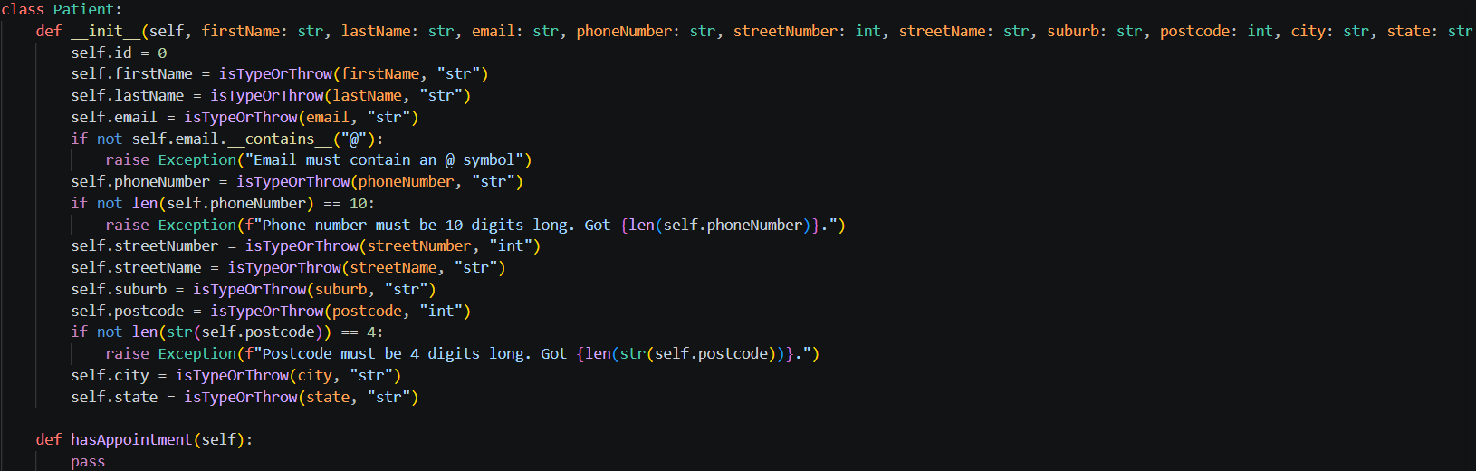

C - Implement Practitioner: AI OFF
Implement Practitioner with identifier, name and specialty; no database logic.
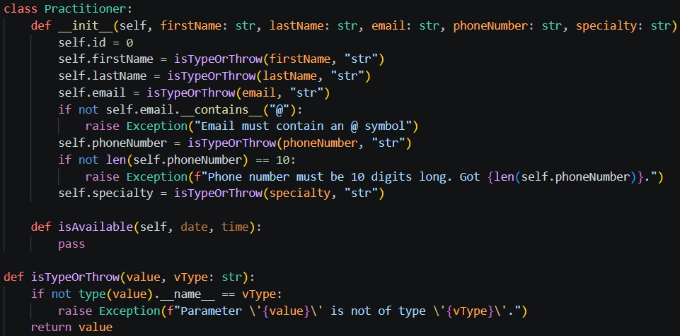

D - Implement Appointment: AI ON
Give AI the approved Appointment UML, business rules and explicit constraints. Ask it to implement only Appointment and agreed enum/exception.

E - Review Generated Code
Check model consistency, unsupported features, public state mutation, unnecessary inheritance, invented dependencies and error handling.

F - Manual Behaviour Checks
Create valid objects, test invalid input, cancel a scheduled appointment and attempt an illegal repeated transition.

G - Refactor
Remove unnecessary code and make implementation simpler and design-consistent.

H - AI Engineering Log
Record prompt, generated contribution, decisions and verification evidence.
Prompt used:
“Act as a Python pair programmer. Implement only the Appointment class from the approved SmartCare UML. Use type hints and an AppointmentStatus enum. Cancelled appointments remain as objects. Do not add database, UI, notification or service classes. Protect status transitions and explain any decision not directly visible in the UML”
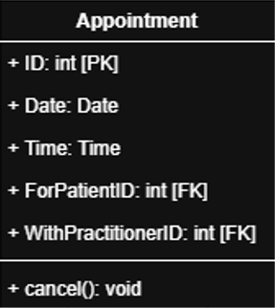

AI response:
“
Based on the UML, the Appointment entity contains only identity, scheduling data, practitioner/patient references, and a cancel() operation. To protect status transitions and support the requirement that cancelled appointments remain as objects, I would introduce an AppointmentStatus enum and keep status changes encapsulated within the class.
Python
from __future__ import annotations

from dataclasses import dataclass, field
from datetime import date, time
from enum import Enum, auto

class AppointmentStatus(Enum):
SCHEDULED = auto()
CANCELLED = auto()

@dataclass
class Appointment:
id: int
date: date
time: time
for_patient_id: int
with_practitioner_id: int

# Not shown in the UML, but required to support cancellation state.
_status: AppointmentStatus = field(
default=AppointmentStatus.SCHEDULED,
init=False,
repr=False,
)

@property
def status(self) -> AppointmentStatus:
"""Read-only access to the appointment status."""
return self._status

def cancel(self) -> None:
"""
Cancel the appointment.

Cancelled appointments remain in memory and retain their identity,
date, time, patient, and practitioner references.
"""
if self._status is AppointmentStatus.CANCELLED:
raise ValueError("Appointment is already cancelled.")

self._status = AppointmentStatus.CANCELLED
Show more lines
Design decisions not directly visible in the UML
- Added AppointmentStatus enum
  - The UML defines a cancel() operation but does not show how cancellation is represented.
  - An explicit enum makes the state visible, type-safe, and extensible.
- Cancelled appointments are preserved
  - cancel() changes status instead of deleting the object.
  - This satisfies the requirement that cancelled appointments remain as objects.
- Protected status transitions
  - _status is private-like (underscore-prefixed).
  - External code can read status through the status property but cannot mutate it directly.
  - Status can only change through domain methods such as cancel().
- Illegal transition prevention
  - Calling cancel() on an already cancelled appointment raises ValueError.
  - This prevents inconsistent state changes.
- No extra concerns added
  - No persistence, database mappings, notifications, services, repositories, UI classes, or scheduling logic were introduced because they are outside the UML scope and your instructions.
”

Suggested AI prompt
Act as a Python pair programmer. Implement only the Appointment class from the approved SmartCare UML. Use type hints and an AppointmentStatus enum. Cancelled appointments remain as objects. Do not add database, UI, notification or service classes. Protect status transitions and explain any decision not directly visible in the UML.

Reflection
Which AI-generated part did you modify or reject? Why? How did the approved design constrain the AI?
The only thing that I changed was that I used the def __init__ instead of implicit property generation. This was done only because it was design consistent. But I would say that it is good this can be done because I think it makes the instantiation code look a lot cleaner than using __init__.
I don’t think it constrained the AI that much. Like, I wasn’t expecting it to import anything to do with Enums, datetime or use decorators.

